**Presenters for 2025 Winter Dreams Summer Gardens**

**Neil Bell**

**Presentation Title:** “Using Woody Plants for Year-Round Interest”

**Presentation Description:**

Woody plants can provide presence year-round in the garden, whether they are deciduous or evergreen. Much of this can be attributed to their size and habit as well as foliage and flower, but also other less remarked-upon characteristic like bark pattern and color or aromatic foliage. We’ll discuss the wide array of shrubs that provide appeal for each season in the mild climate of the Rogue Valley.

**Bio:**

Neil Bell was Community Horticulturist for the Oregon State University Extension Service in Marion County and Polk County from 2000 to 2021, overseeing both County Master Gardener programs during that time. He has also conducted numerous landscape evaluations of shrubs for unirrigated landscapes since 2000, including *Ceanothus*, *Cistus*, *Grevillea* and manzanita. He is still employed one day per week by Extension to assist with evaluation of 116 olive cultivars at the North Willamette Research and Extension Center in Aurora.

Neil lives on 5 acres of Polk County bush west of Monmouth, where he continues to learn how to garden with wildlife, plentiful weeds and limited water.

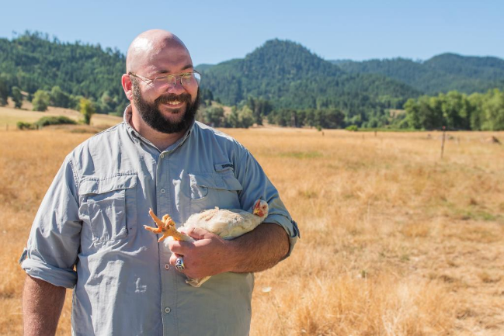**Logan Bennett**

**Presentation Title:** “How to Manage Blueberries, Caneberries, and Strawberries in Your Home Garden”

**Presentation Description:**

Join us for an engaging and informative session on how to manage Blueberries, Caneberries, and Strawberries in your home garden! This talk will delve into the specific environmental needs of each crop, the common pests you might encounter, and the best practices for pruning and fertilizing. Whether you're a seasoned gardener or just starting out, you'll gain valuable insights on how to cultivate these delicious berries successfully at home. Don't miss this opportunity to enhance your gardening skills and enjoy a bountiful harvest!

**Bio:**

Logan Bennett holds a Master's Degree in Soil Science and a Bachelor's in Natural Resources Management. With three years of experience as an extension agent at Oregon State University, working as part of the Small Farms and Master Gardeners Program. Previously, Logan worked as a crop consultant specializing in perennial crops.

Logan's interests include Direct Farm Marketing, soil science, hogs, poultry, blueberries, and apples. Logan has expertise in soils, integrated pest management, permanent cropping systems, and small fruits, making him a valuable resource for farmers and gardeners alike

**James Cassidy**

**Presentation Title: Soil! – What it is & How it works…**

**Presentation Description:** It's ALL about SOIL! Most people only have a vague idea of what soil is and how it works. You will learn more than you ever thought possible from this lecture. What soil is, how soils form, the reason you are alive, what nutrients are, how soil stores water and nutrients, how to access published on-line soils data to improve your understanding of this critical resource! The fundamentals that ALL humans on the planet Earth should know!

**BIO:** James Cassidy has been an Instructor of Soil Science at Oregon State University for over 20 years. The introductory class now has over 100 students each term and is very popular. James is also the founder and faculty advisor for the wildly popular OSU Organic Growers Club - OSU's student farm. Coming from a non-traditional background (music industry for over 40+ years) he is passionate about soil and is popular with students because of his dynamic speaking style. The student farm project has over 300 student volunteers on it's list-serve and continues to grow. Over 25,000 students have participated in the farm’s programs.  The farm is largely self-supported through produce sales and cultivates over 50 different fruit and vegetable crops and is in it's 25th season.

**Robert Coffan**

**Presentation Title:**

“Our Western Monarchs: Will they be Listed as “THREATENED”, and Why Should We Care?”

**Presentation Description:** In 2019, the total known population of Western Monarchs plummeted to a scant 20,500 – a 99.4% loss in the last 20 years - followed by another ten-fold drop to less than 2,000! What happened and why? Will they be listed as “Threatened”? Can they recover? What can we do to help? The presentation will include an introduction to the iconic monarch butterfly, some of the issues that plague our migrating western population, and share what we can do to help restore monarch habitat and help many other pollinators throughout the seasons.

**Bio:**

Robert Coffan, Co-founder of Southern Oregon Monarch Advocates. Founder and former Chair of Western Monarch Advocates. He has a BS in hydrogeology and is a former Adjunct Professor at Southern Oregon University. Robert has lived in the Rogue Valley for 25 years, enjoying researching the biodiversity of the basin. He is fascinated by the beauty and life processes of the Monarch butterfly and other pollinators, and has joined forces with others to help restore their habitat and bring the population back. Robert never loses sight of the importance of preserving and caring for this beautiful and diverse part of the world we call home on planet Earth.

**Jane Collier**

**Presentation Title:** “De-Bunking Gardening Myths”

**Presentation Description:** Did you know that coffee grounds are not acidic, or that grass clippings do not cause thatch? Or do you think drought tolerant plants don’t need watering? This presentation will de-bunk these gardening myths and many more.

**Bio:** Jane Collier is an Oregon State University Extension Master Gardener who teaches for the award-winning 10-Minute University™ Program. Jane’s gardening knowledge encompasses growing vegetables and small fruits, insect pests, and container gardening. Today, she and her husband farm their five-acre home garden which yields a bounty each year.

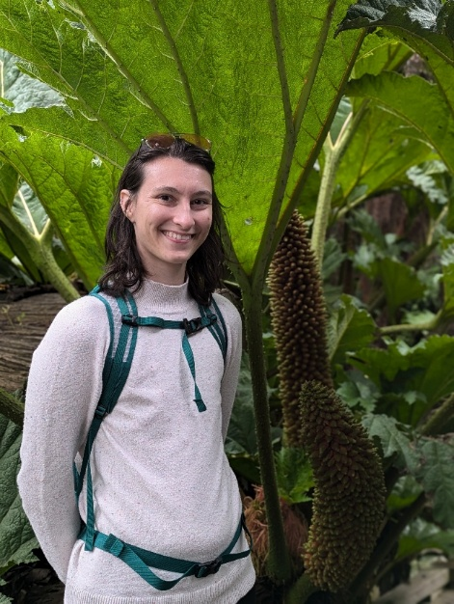

**Grace Florjancic**

**Presentation Title:**  “Achieving Abundant Apples: Pruning and Training Home Orchards”

**Presentation Description:** Pruning and training fruit trees is a journey that begins in year one. Proper pruning can not only increase your yield of fruit but also improve your tree’s overall health. In this presentation we will focus on apples, but the same concepts apply from almonds to Bartlets to cherries. Join Grace Florjancic in this presentation to learn the guidelines for pruning your trees through the years.

**Bio:** Grace Florjancic is the Master Gardener Coordinator for Jackson County. Grace has a degree in microbiology and horticulture form Virginia Tech. Part of their undergraduate research included management of the research apple orchard and the installation of a new orchard. Prior to her work with OSU Extension, she has worked in research greenhouses and botanic gardens in Virginia.

**Scott Goode**

**Presentation Title:**

. “Introduction to Soil: Physical and Biological”

**Presentation Description:** This class will touch on how soils form, what comprises a healthy soil, how the life-forms in the soil are organized and what we can do to promote a healthy soil.

**Bio:** Scott Goode is a retired environmental scientist who worked in water treatment, bioremediation, and modeling the role of environmental factors in soil chemistry. He is currently developing carbon removal and petroleum-free farming technologies.

**Brian Hendrix**

**Presentation Title:** “Fire Adapted Landscaping Best Practices and Understanding Defensible Space”

**Presentation Description:** Designed to help gardeners improve their understanding of what “being Fire Adapted” really means for gardens and landscaping and how these best practices work together with home hardening techniques to best protect your home and property from wildfire risks. We’ll utilize a Master Gardener’s home risk assessment to introduce terms and activities relating to wildfire mitigation, learn basics about effective plant spacing and maintenance for improved defensible space and differences between a “Firewise” or “Flammable” plant.

**Bio :** Brian Hendrix is the Fire Adapted Communities Coordinator for Ashland Fire & Rescue. He has served since 2017 and is a Certified Wildfire Mitigation Specialist. Before taking over the FAC Coordinator role in 2021, Brian was the Weed Abatement Coordinator and a Wildfire Mitigation Specialist for AF&R’s Wildfire Division. Brian lives in Ashland with his wife and 3 sons.

**Drs. Alan Journet & Kathy Conway**:

**Presentation Title: “**Electrifying Yard Work & Landscaping”

**Presentation Description:** Have you ever thought of trading in your noisy gas powered yard equipment for quieter electrical tools that start with the flick of a button? Kathy and Alan will discuss the merits of electrifying, what electric yard equipment is available, and the cost to you. We will start by exploring why electrification is generally favored amongst those of us concerned about climate change issues and what the benefits are for the everyday user of yard equipment. We will then identify what kinds of yard equipment are available locally in electric powered models; we will also discuss the cost of these items both in terms of purchase price and operation. We plan to provide information appropriate for professional landscapers and gardeners.

**BIOS:**

Alan hails from the UK where he attended the University of Wales, earned a doctorate in entomology from McGill University (Montreal) and then undertook a four-year excursion to Australia. After decades teaching Biology and environmental science at Southeast Missouri State University, he retired in 2010.

Native Oregonian Kathy Conway attended Southern Oregon College, University of Oregon, and Lewis and Clark College. She then earned a doctorate in curriculum and instruction at Southern Illinois University. Kathy taught high school and then university level in the areas of mathematics and methods of teaching math, science, and social studies to preservice elementary students at Southeast Missouri State University. She also retired in 2010.

Upon retirement, Kathy and Alan relocated to Southern Oregon, built an energy efficient passive/active solar home in the Applegate Valley, and collaborated with area residents to form Southern Oregon Climate Action Now where they serve as co-facilitators. Currently, at SOU, they teach ‘Living with Climate Change: Rogue Valley.’ They are the proud owners of several electric yard tools and recently purchased a battery-powered electric vehicle.

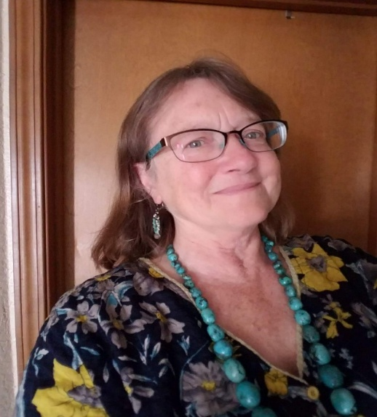**Lynn Kunstman**

**Presentation Title:** “Oregon Butterflies and the Native Plants that Host Them”

**Presentation Description**: North American insects have evolved to feed on native plants. If we want to increase the number and variety (abundance and diversity) of butterflies in our yards and gardens, we need to plant those plants on which their larvae feed. Each family of plants hosts a specific suite of butterflies, with whom they share evolutionary relationships. In some cases, a single Genus of plant hosts a specialized lepidoptera species - as with milkweed

*(Asclepias)* and the monarch butterfly. This presentation will show you Oregon’s beautiful native butterflies, and the plants that support them. Get ready to add some winged color to your yard by choosing native plants!

**Bio:** Lynn Kunstman began gardening with her parents in Lafayette, California, as aof young child. She has a degree in Wildlife Management from Humboldt State

University and, after moving to Ashland in 1986 obtained a Master’s of Science in Education from SOU. After teaching middle school special ed and science for 22 years, she retired, to Medford, where she grows a huge vegetable garden; harvesting and preserving food crops year-round. She became a Master Gardener in 2012, and a Master Food Preserver in 2013. Most recently her focus has been on gardening for wildlife and pollinators. Lynn is the Master Gardener Speaker on the monthly gardening show Garden for Life, on Jefferson Public Radio.

Her quarter acre lot in Medford is certified as a Monarch Way Station, a Pollinator Garden, and a Wildlife Habitat. In 2023 she was named Oregon State Master Gardener of the Year. She established and runs the native plants nursery at Jackson County Extension Campus. She also rears, tags and releases monarch butterflies, as part of a citizen science effort through University of Washington.

**LeAnn Locher**

**Presentation Title:** “What’s your garden future? Talking climate change with Oregon’s gardeners.”

**Presentation Description:**  Across Oregon, gardeners are noticing the impacts of climate change and adapting their practices in creative and meaningful ways. In this session, we’ll share what we’ve heard from hundreds of gardeners—what they’re seeing, what they’re doing, and what support they need most. We’ll also introduce the *Garden Future* campaign, a statewide effort to support climate-resilient gardening with practical tools, resources, and community connections. Join us to explore how your garden can grow a more resilient future.

**BIO: LeAnn Locher** is an award-winning communications strategist with more than 20 years of experience spanning national agencies, nonprofit consulting, and higher education. At Oregon State University Extension, she serves as the lead communication strategist for the Master Gardener program, where her work has earned national recognition for public engagement and outreach. LeAnn is the strategist behind *Garden Future*, a statewide initiative that explores how Oregon gardeners are experiencing and responding to climate change. Her work focuses on co-creating a climate-resilient gardening culture grounded in science, community values, and practical action. She is the Statewide Outreach Coordinator, OSU Extension Master Gardener program.

**Andony Melathopoulos**

**Presentation Title:**  “Right plant, right bee: Matching bees to flowering plants with the new Melittoflora tool.”

**Description:** Oregon has the richest dataset of bee-plant interactions in the U.S., thanks to almost 100,000 observations made by volunteers Master Melittologist. We explore this data using the new Melittoflora tool designed to help make you make more precise plant selections in your garden.

**Bio:** Andony Melathopoulos is an Associate Professor of Pollinator Health Extension and leads up the Master Melittologist program, which is the first program in the U.S. dedicated to surveying wild bee populations. He is also the host of the weekly podcast PolliNation.

**Susie Savoy**

**Presentation Title:** “Native Equivalents for Common Nursery Plants”

**Presentation Description:** Non-native ornamental plants support 29 times less biodiversity than native ornamentals; however, most plants sold in nurseries are not native. Thankfully, some local nurseries and plant growers are working hard to supply the growing interest in native plants and there is a wide selection of native plants to choose from that can replace non-native ornamentals. Come learn how to help native pollinators and biodiversity by growing native equivalents for common nursery plants such as aster, checker mallow, clematis, coneflower, currant, fuchsia, honeysuckle, iris, lupine, turtlehead, redbud, sunflowers, and much more!

**Bio:**

Suzie Savoie is co-owner of Siskiyou Ecological Services and Klamath-Siskiyou Native Seeds and is co-author of *Native Pollinator Plants for Southern Oregon*.Suzie provides native seed collection services, online native seed sales, native nursery plants, and native plant consultation. For 21 years she has been using native plants for gardens and habitat restoration on her property in the Applegate Valley, and she enjoys helping others do the same.

**Rhianna Simes**

**Presentation Title:** From Soil to Soul: Regenerative Veggie Gardening

**Presentation Description:**Grow Regeneratively: Healthy Soil, Healthy Food, Healthy You. We will cover how to incorporate veggies into a beautiful garden and landscape that feeds your family, tips on what grows well, seed selection, and ideas for season extension.  If you are what you eat, you wanna grow something really good! Come learn how!

**Bio:**Rhianna Simes (wry-anna, Sims) recently retired from 10 years as an instructor at the Oregon State University Extension Service, where she developed the Land Steward program, and also coordinated the Master Gardener program for several years. Rhianna earned a Master’s of Science in Education and Botany from Southern Oregon University in Ashland, as well as a certificate in Plant Pathology from OSU.

Rhianna lives with her husband and two young children outside Phoenix, OR where they operate their own certified organic farm called Verdant Phoenix Farm & Nursery ([verdantphoenix.com](https://na01.safelinks.protection.outlook.com/?url=http%3A%2F%2Fverdantphoenix.com%2F&data=05%7C02%7C%7Ccf47475498c348d7288808ddb52d20a2%7C84df9e7fe9f640afb435aaaaaaaaaaaa%7C1%7C0%7C638865927643216840%7CUnknown%7CTWFpbGZsb3d8eyJFbXB0eU1hcGkiOnRydWUsIlYiOiIwLjAuMDAwMCIsIlAiOiJXaW4zMiIsIkFOIjoiTWFpbCIsIldUIjoyfQ%3D%3D%7C0%7C%7C%7C&sdata=SlsfXbRsoJlrlzBwbRWyABxVgaDnnMUBQdwvv9vyRAQ%3D&reserved=0)) which specializes in organic plant starts, basketry willow, perennial food, healthy soil and natural farming. Rhianna is also a nonprofit consultant and grant writer with Growing Assets for Nonprofit Excellence

**Lucretia Weems**

**Presentation Title:** “Lawn Alternatives”

**Presentation Description:** Are you curious about expanding some or all of your landscape beyond traditional grass lawn? Join us in exploring a number of sustainable and attractive options and learn more about the growing Unlawning Movement.

**Bio:** Classically trained in the UCLA Landscape Architecture program, Lucretia Weems has been gardening and designing landscapes in the Rogue Valley for over 20 years. She has been taking out lawn at her own homes for even longer!

**Zach Wooldridge**

**Presentation Title:**  
“The Basics of Limnology: Water Cycle, Nitrogen Cycle, and Wellness Benefits from Water Features “

**Presentation Description:**

During my presentation I will be discussing the positive effects of water, being near water and the wellness that the sound of water can bring. I’ll also discuss how water gardens and hydroponics improve upon and bolster our traditional gardens.

**Bio**

Zach Wooldridge is the owner of Neptune's Ponds and Water Gardens. He has over 20 years of construction experience getting his start in excavation and large-scale farm ponds. These days he designs and builds custom water features including Koi ponds, swim ponds, waterfalls and backyard oases. He's not just a builder - he's an artist at heart known for creating peaceful, nature-inspired beautiful spaces. In his free time he enjoys playing pickleball and spending time with his wife and 3 kids.